Simulation Report of Forest Fire Spreading Modelling

# Background

For a forest filled with unoccupied areas, and trees that may or may not be on fire, the purpose of this study is to detail how cellular automation models responsible for spreading the fire have been implemented. The models spread the fire throughout the forest based on a set of assumptions that although some trees don’t catch fire easily due to their immunity, others catch fire when they are influenced by a something. And for the purpose of this study, the recognized burning influences considered in the model implementation are lightning strikes on the forest and nearness to a tree that is on fire. Both burning influences can cause fire at any time in the forest if the trees are not immune to fire. Following that, the model has been implemented using two methods, parallel and sequential implementation.

# Simulations and Modelling

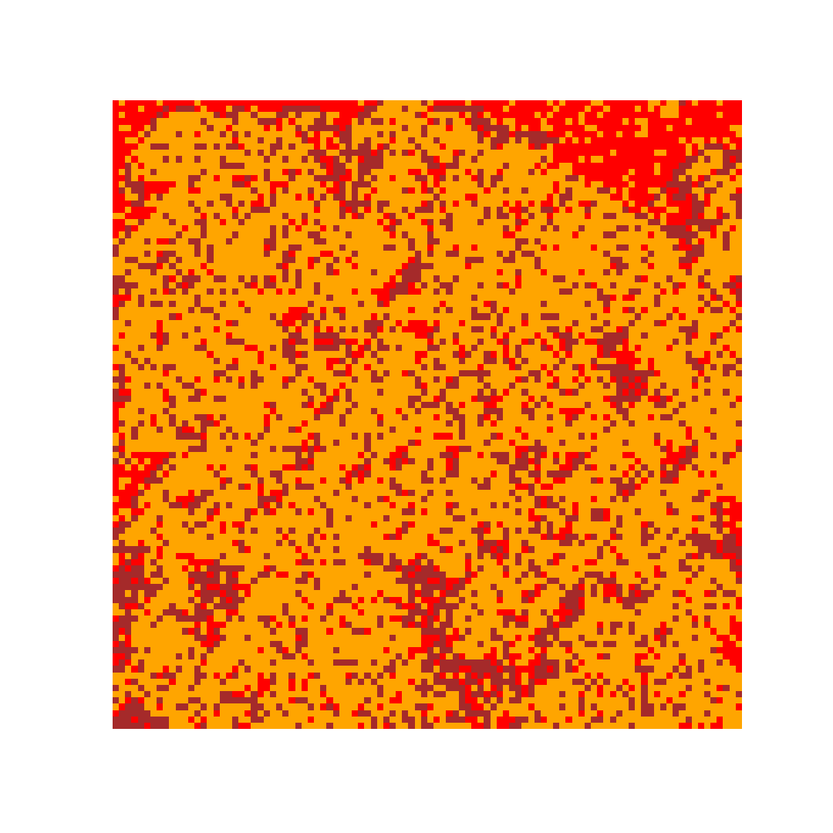

# Results and Implementations

|  |  |  |
| --- | --- | --- |
| Site Size | Sequential | Parallel |
| 100 X 100 | 0.054 | 0.039 |
| 400 X 400 | 0.68 | 0.59 |
| 800 X 800 | 2.34 | 2.30 |
| 1000 X 1000 | 6.12 | 3.74 |
| 1200 X 1200 | 9.39 | 6.23 |
| 2000 X 2000 | 18.71 | 14.84 |

# Conclusion

# References